SPOTIFY 2023 DATA ANALYSIS
Business Intelligence Report Using Microsoft Power BI_(Lab MST-1)

Student Name: KONGHO SEYDOU CISSE UID:24BAI70013
Programme: (AI & ML) University: CU
Supervisor: Ashiq Bat
Dataset: spotify-2023.csv

Report Purpose
This report presents a Business Intelligence analysis of the Spotify 2023 dataset. Microsoft Power BI is used to transform the available music data into interactive dashboards and visual insights covering streaming performance, playlist exposure, chart activity, artist performance, platform indicators, and tempo-based analysis.
1. Introduction
Music platforms generate a huge amount of data every day. Every song can have different numbers of streams, playlist appearances, chart positions, and other characteristics. Looking at these values individually can make it difficult to understand the bigger picture. This is where data analysis and Business Intelligence tools become useful.
For this project, I worked with the Spotify 2023 dataset and used Microsoft Power BI to explore the information in a visual and interactive way. The dataset contains details about songs and artists along with their streaming numbers, playlist presence, chart performance, and musical features such as BPM, danceability, energy, valence, and acousticness.
I designed the Power BI report as six pages, with each page focusing on a different part of the dataset. The report starts with an overall view of song performance and then moves towards more specific areas such as platform performance, playlist and chart activity, artist and song performance, and the relationship between BPM and streams.
Instead of looking only at individual numbers, I used different types of visualizations to make comparisons easier. Bar and column charts were used for comparing groups and rankings, KPI cards were used for important summary values, and scatter charts were used to look for possible relationships between numerical variables.
The main aim of this project is to understand what the available data can show about song performance and to present those observations in a simple and understandable form. The analysis is based only on the information contained in the dataset, so the patterns identified should be considered observations rather than proof that one factor directly causes another.
Through this project, I also gained practical experience in preparing data, creating visualizations, working with calculated measures, and building a complete Business Intelligence dashboard in Power BI.
2. Objectives of the Project
The main objective of this project is to use Microsoft Power BI to explore the Spotify 2023 dataset and turn the available song data into clear and useful visual information.
The specific objectives of the project are:
- To understand the Spotify 2023 dataset by examining information related to songs, artists, streams, playlists, charts, and musical features.
- To prepare and organize the data so that the different fields can be used correctly for analysis and visualization in Power BI.
- To analyse song performance using streaming numbers and other indicators available in the dataset.
- To compare playlist and chart performance and observe how these indicators vary between songs.
- To examine artist and song-level performance and identify differences in streaming activity among artists and individual tracks.
- To investigate the relationship between BPM and song performance by grouping songs according to their tempo and comparing their streams, playlist presence, and chart performance.
- To present the analysis through an interactive dashboard using suitable Power BI visualizations that make the results easier to understand and compare.
- To develop practical Business Intelligence skills by working with data preparation, calculated measures, visual analysis, and dashboard design.

3. Dataset Description
For this project, I used the spotify-2023.csv dataset. It contains information about songs and artists along with different indicators that can be used to understand their popularity and performance. The dataset combines streaming information, playlist appearances, chart positions, and several musical characteristics in one table.
One of the main fields used in the analysis is streams, which represents the number of streams associated with a song. I also used platform-related fields such as Spotify playlist and chart counts, along with Apple Music and Deezer indicators. These fields made it possible to compare how songs are represented across different music platforms.
The dataset also includes information about the songs themselves, such as the track name, artist name, and release year. In addition, musical features such as BPM, danceability, energy, valence, and acousticness were used to investigate whether musical characteristics show any visible relationship with song performance.
The following table summarizes the main fields used in the Power BI analysis:
Category | Fields Used
Song Information | track_name, artist(s)_name, released_year
Streaming | streams
Spotify | in_spotify_playlists, in_spotify_charts
Apple Music | in_apple_playlists, in_apple_charts
Deezer | in_deezer_playlists, in_deezer_charts
Shazam | in_shazam_charts
Musical Features | bpm, mode, danceability_%, energy_%, valence_%, acousticness_%
These fields were selected because they directly support the questions explored in the dashboard. For example, streaming and playlist fields are useful for studying song popularity, while BPM and other audio features allow the musical side of the dataset to be examined.
Overall, the dataset provided enough information to analyse the songs from both a performance perspective and a musical-characteristics perspective, which formed the basis of the Power BI report.

4. Tools and Technologies Used
The project was completed using a small set of tools that were sufficient for importing, preparing, analysing, and presenting the Spotify dataset.
4.1 Microsoft Power BI
Microsoft Power BI was the main tool used for this project. It was used to import the CSV dataset, prepare the data, create calculated measures, and build the six-page interactive report. Different charts and cards were used to present the results in a way that makes comparisons easier to understand.
4.2 Power Query
Power Query was used during the data preparation stage. It helped in checking the imported columns, reviewing data types, and preparing the dataset before it was used in the report.
4.3 DAX
Data Analysis Expressions (DAX) was used to create calculated measures required for the analysis. Measures such as total streams, total songs, average streams, and average BPM helped provide summary values and support the different dashboard visuals.
4.4 CSV Dataset
The source file used for the project was spotify-2023.csv. Since the data was provided in CSV format, it could be directly imported into Power BI and prepared for analysis.
4.5 Report Visualizations
Power BI visualizations such as bar charts, column charts, scatter charts, tables, and KPI cards were used throughout the report. Each visual type was selected according to the information that needed to be compared or investigated.
5. Data Preparation and Transformation
Before creating the dashboard, the Spotify dataset was checked and prepared in Power BI so that the fields could be used correctly in the different visualizations. This step was important because the quality of the final charts depends on how the source data is interpreted and organized.
First, the spotify-2023.csv file was imported into Power BI using the Text/CSV option. After importing the file, the columns were reviewed to understand the type of information available in each field.
The data types of the columns were then checked. Text fields such as song names and artist names were kept as text, while numerical fields such as streams, BPM, playlist counts, and chart counts were prepared as numerical values. This allowed Power BI to perform calculations such as sums and averages correctly.
The dataset was also reviewed for blank or missing values. Particular attention was given to platform-related columns because an empty value does not always mean that the actual value is zero. The available information was therefore handled carefully during the analysis.
For the dashboard, calculated measures were created where summary values were required. These measures were used for values such as total streams, total number of songs, average streams, and average BPM.
BPM was also used for the final analysis page. The tempo values were grouped into ranges so that songs with similar BPM values could be compared more easily. This made it possible to examine average streams, playlist presence, and chart performance across different tempo groups.
After the required preparation was completed, the changes were applied and the data was loaded into the Power BI report. The prepared dataset was then used to create the six dashboard pages and their respective visualizations.
BPM Group Classification
BPM Group | BPM Range | Meaning
Slow | Below 80 | Lower-tempo songs
Moderate | 80–119 | Medium-tempo songs
Fast | 120–139 | Faster, upbeat songs
Very Fast | 140 and above | High-tempo songs

6. DAX Measures and Calculations
During the development of the Power BI dashboard, DAX (Data Analysis Expressions) was used to create measures for values that needed to be calculated dynamically. These measures helped summarize the dataset and were useful when displaying overall statistics or comparing different groups.
The main calculations used in the report are shown below.
Measure | DAX Expression | Purpose
Total Streams | SUM('spotify-2023'[streams]) | Calculates the combined streams represented in the dataset.
Total Songs | DISTINCTCOUNT('spotify-2023'[track_name]) | Counts the unique songs in the dataset.
Average Streams | AVERAGE('spotify-2023'[streams]) | Finds the average number of streams per song.
Average BPM | AVERAGE('spotify-2023'[bpm]) | Calculates the average tempo of the songs.
These measures were mainly useful for KPI cards and summary-level analysis. For example, Total Streams gives an overall view of streaming activity, while Average Streams provides a way to compare the general streaming level across different parts of the dataset.
The measures also make the report more flexible because Power BI recalculates them when the data is filtered. This allows the displayed results to change according to the selected data rather than relying only on fixed values.
For the BPM analysis, the original BPM values were also grouped into tempo ranges. This made it easier to compare songs with similar tempos and examine how their average streams, playlist presence, and chart performance differed.
Overall, DAX helped turn the raw numerical columns into useful summary information that could be directly incorporated into the dashboard.

7. Dashboard Design and Visualization Approach
The dashboard was designed in Microsoft Power BI to make the Spotify 2023 dataset easier to understand through visual analysis. Instead of presenting all the information in tables, different types of charts were selected according to the type of comparison or relationship being studied. The main idea was to keep the report simple, readable, and focused on the performance of songs, artists, platforms, playlists, charts, and musical characteristics.
7.1 Use of KPI Cards
KPI cards were used to display important summary values such as total streams, total number of songs, average streams, and average BPM. These values provide a quick overview of the dataset before looking at the detailed charts.
7.2 Use of Bar and Column Charts
Bar and column charts were used for ranking and comparison. For example, they were useful for showing songs with high playlist exposure, songs with strong chart performance, artist streaming performance, and average performance across different BPM ranges. These charts make it easier to compare categories without having to read every individual value.
7.3 Use of Scatter Charts
Scatter charts were included when the purpose was to examine whether two numerical variables showed any visible relationship. In this report, scatter plots were used for comparisons such as Spotify playlist exposure against chart performance, playlist exposure against streams, and BPM against song streams. These visuals help identify general patterns, clusters, and unusual values in the dataset.
7.4 Use of Detailed Song and Artist Information
Song names and artist names were included in relevant visuals so that the analysis could be connected to individual tracks and artists. This makes the dashboard more useful because the user can move from an overall summary to specific song-level or artist-level performance.
7.5 Consistent Dashboard Structure
Each page was given a clear title based on its purpose. Related visuals were placed together so that the information could be understood from one section to another. The dashboard was kept focused on comparisons and performance indicators rather than adding unnecessary visuals.
Overall, the visualization approach helped convert the raw Spotify dataset into a more understandable Business Intelligence report. Power BI made it possible to combine numerical calculations with visual comparisons, making the final analysis easier to interpret and present.

8. Analysis Approach
For this project, I used Microsoft Power BI to explore the Spotify 2023 dataset from different angles. Instead of looking at the data only as numbers, I focused on the six analysis tasks given in the coursework and used charts and comparisons to understand what was happening in the dataset.
8.1 Platform Comparison
I compared the available Spotify, Apple Music, Deezer, and Shazam information to see how songs performed across different platforms. Streams, playlist presence, and chart performance were used to identify songs that performed well on multiple platforms as well as songs that showed different results from one platform to another.
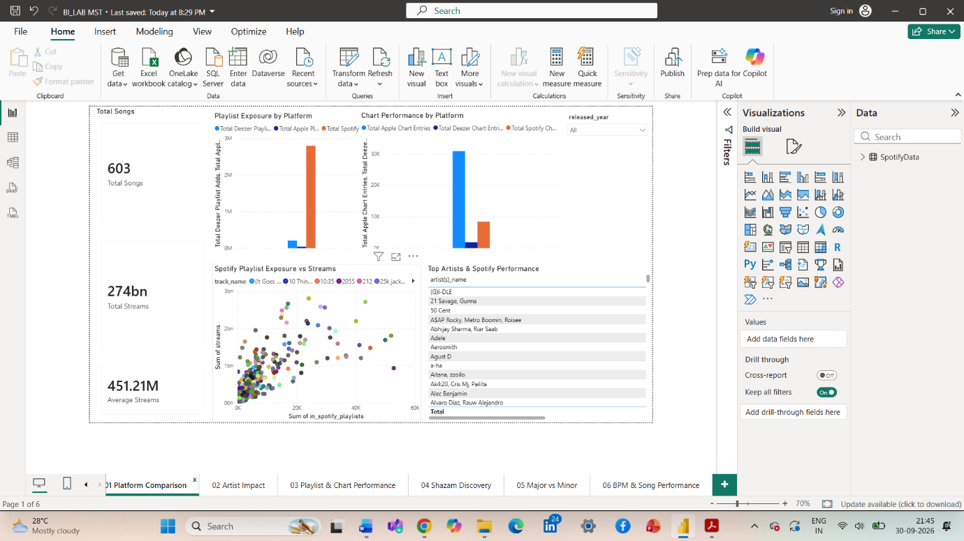

8.2 Artist Impact
This part focused on the connection between artists and song performance. I compared artists and songs using streams, playlist exposure, and chart performance. This helped me see which artists or songs had stronger visibility and whether artist involvement was reflected in their overall performance.
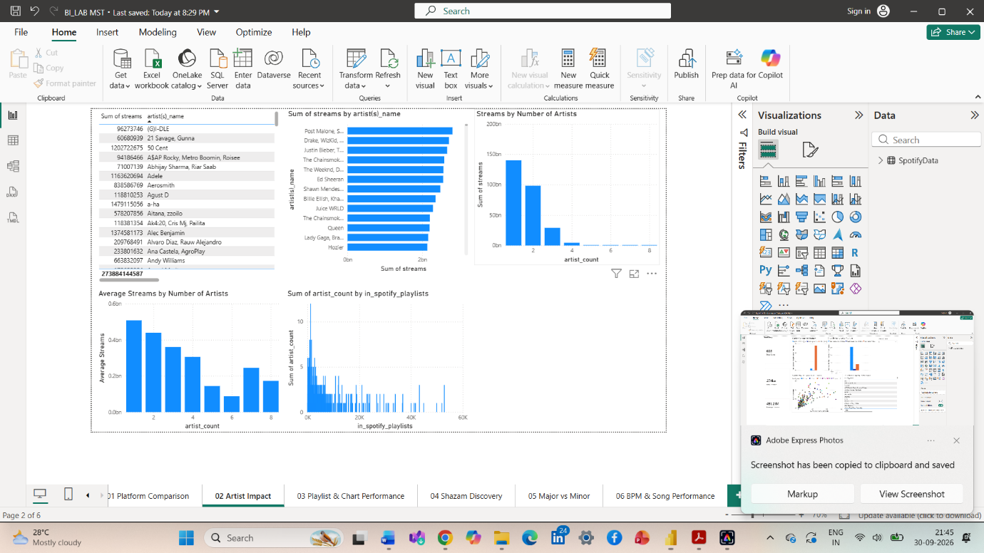
8.3 Playlist Exposure and Chart Performance
Here, I looked at whether songs with more playlist exposure also had better chart performance. I used Power BI charts to compare playlist numbers with Spotify chart positions and to identify songs that stood out from the general pattern.
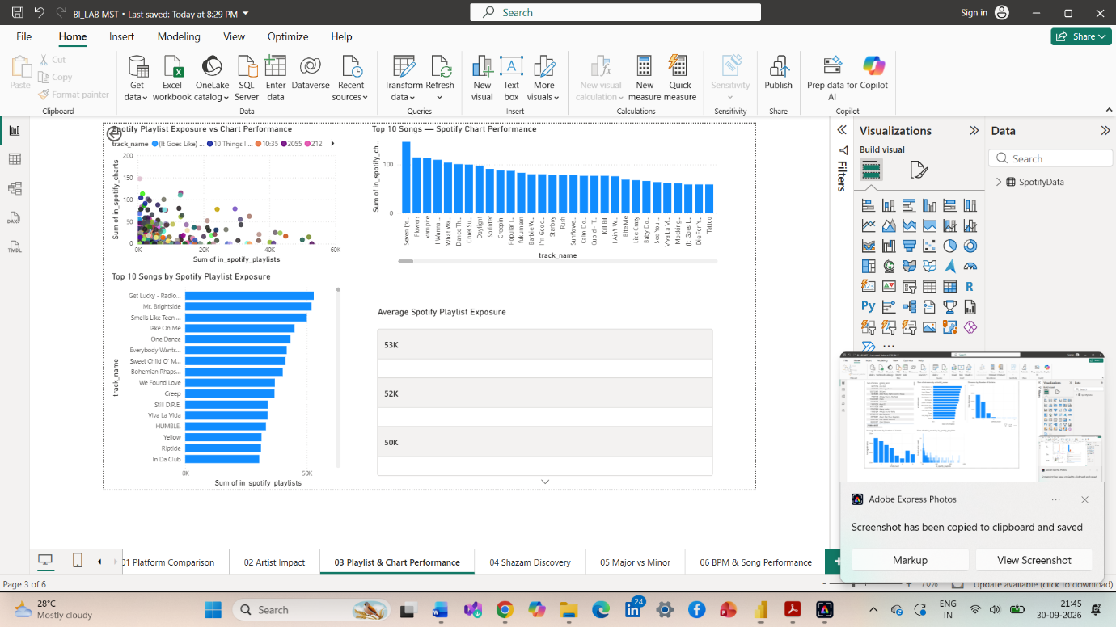

8.4 Shazam Discovery Analysis
I also examined Shazam activity and compared it with other performance indicators such as streams and playlist presence. This made it possible to see whether songs discovered or searched through Shazam were also performing strongly on other music platforms.
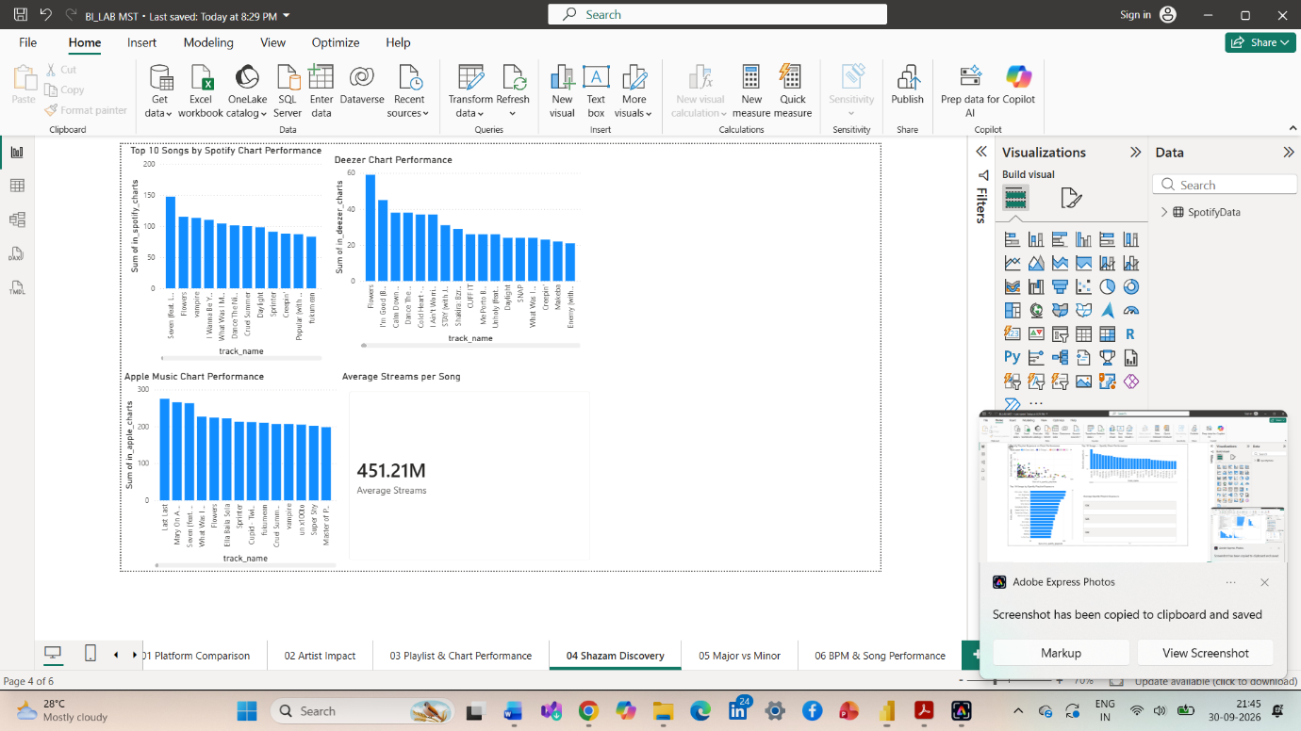

8.5 Major vs Minor: Key and Mode Analysis
For this analysis, songs were compared based on their musical mode, mainly Major and Minor. I considered streams together with characteristics such as danceability, energy, valence, acousticness, and BPM to see whether the two groups showed noticeable differences.
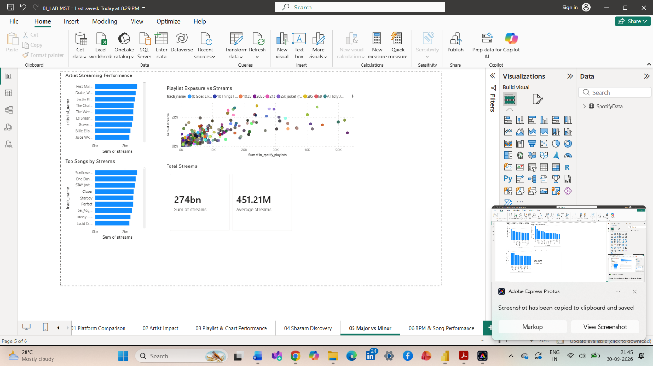

8.6 BPM and Song Performance Analysis
Finally, I studied whether song tempo had any visible connection with performance. The songs were divided into BPM ranges and compared using streams, Spotify playlist presence, and chart performance. This helped me understand which tempo ranges were common in the dataset and whether they showed different performance patterns.
The purpose of these analyses was not to predict which songs would become successful. Instead, the aim was to understand the patterns already present in the Spotify 2023 data and present them clearly through Power BI.
